Our Ref: _______________ Your Ref: ________________________ Date: __________________

Baptist Church

Baale Yaku Site Area, P. O. Box 644,

Ogbomoso, Oyo State. Tel. 07052425407

Email: [newsprinbaptistchurch@gmail.com](mailto:newsprinbaptistchurch@gmail.com)

Website: newspringbc.comze.com

NEW SPRING

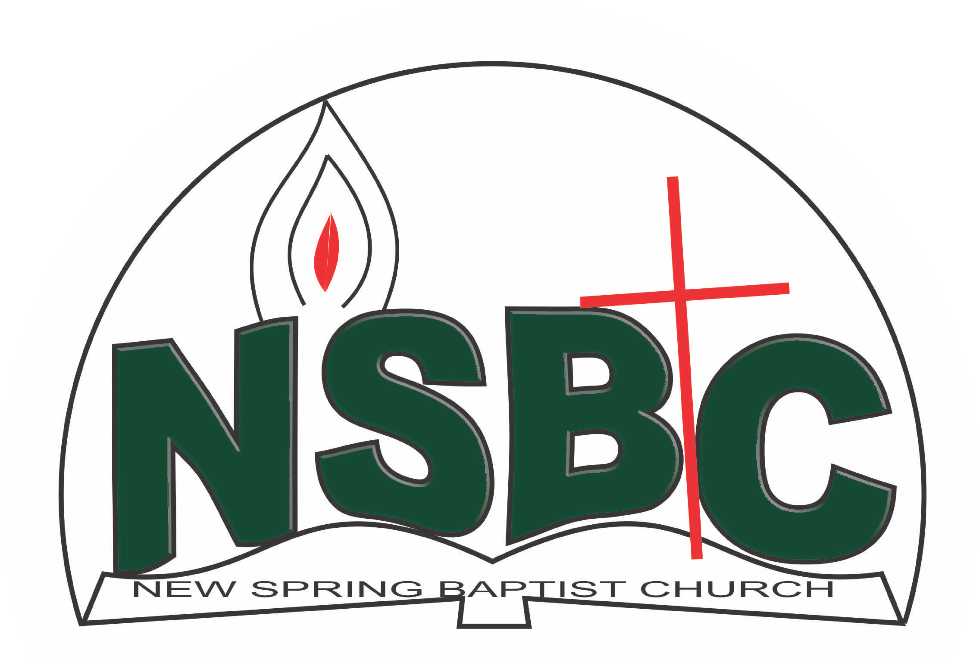

2 January 2022

Dear Dns. Christiana Oketoobo,

Nomination to Serve as a Worker in the Church in 2022.

Calvary greetings in the precious name of our Lord and Saviour Jesus Christ. It is our pleasure to inform you that at the Church-in-Conference held on December 19, 2021; the Church ratified your nomination to serve in the following areas between January 1 and December 31,2022:

1. Member, Beautification & Decoration Committee under the chairmanship of Mr. Akin Ogunlowo
2. Member, Church Usher under the chairmanship of Mr. Nathaniel Oyekunle
3. Deaconess
4. Chairman, Counselling & Follow-up Committee
5. Member, Intercessors’ Committee under the chairmanship of Mrs. Funke Oyekunle
6. Member, Benevolence Committee under the Chairmanship of Dn. Dele Olatubosun
7. Member, Mission and Evangelism Committee under the chairmanship of Dn.Dr. Ayinde Ezekiel

Please refer to the table below for the key functions of each of these roles. Details can be found in the Church constitution. You are strongly encouraged to become familiar with the tasks as stated in the document. There will be an orientation of the Church workers on January 22, 2022 at 8:30 a.m. on the church premises. Please ensure you participate in this training.

“Now it is required that those who have been given a trust must prove faithful. I Corinthians 4:2”. May God find you faithful in the task He has assigned to you.

| Domain | Key function of Office, Department or Committee |
| --- | --- |
| Beautification & Decoration Committee | Responsible for the ornamentation of the Church building and premises |
| Usher | To provide support to the Church Pastor in guiding members and visitors to appropriate seating locations before and during service |
| Deacons1 | To provide support to the Church Pastor in the effective ministry of the Church to its members, those under spiritual watch care of the Church and the community at large |
| Counsellling & follow-up Committee | To help decision makers understand and follow through on their decisions |
| Intercessors’ Committee | Responsible for standing in the gap on behalf of the Church and her members |
| Benevolence Committee | The committee is responsible for the implementation of the benevolence policy of the Church |
| Member, Mission & Evangelism Committee | Responsible for the mobilization of Church members for soul winning activities. |

Thank you for accepting to serve in this Church.

Yours in His service

Olusayo Okediji Blessed Agboola

Church Secretary Chairman, Nominating Committee

1Deacons are elected in the first instance for 5 years (so you will serve till 2023)